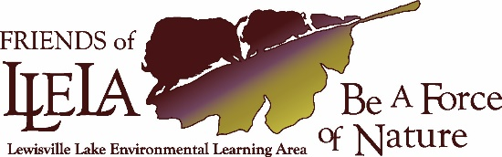
2021 LLELA Scavenger Hunt
Team Name | Click or tap here to enter text.
Captain’s email address | Click or tap here to enter text.
Captain & Team Members | Click or tap here to enter text.
Click or tap here to enter text. | Click or tap here to enter text.
Click or tap here to enter text. | Click or tap here to enter text.

If possible, load the app iNaturalist on your phone for help in identifications.
Here’s an example:
To the early settlers the CrossTimbers was known as the (cast iron) forest because of the difficulty they had getting through it.
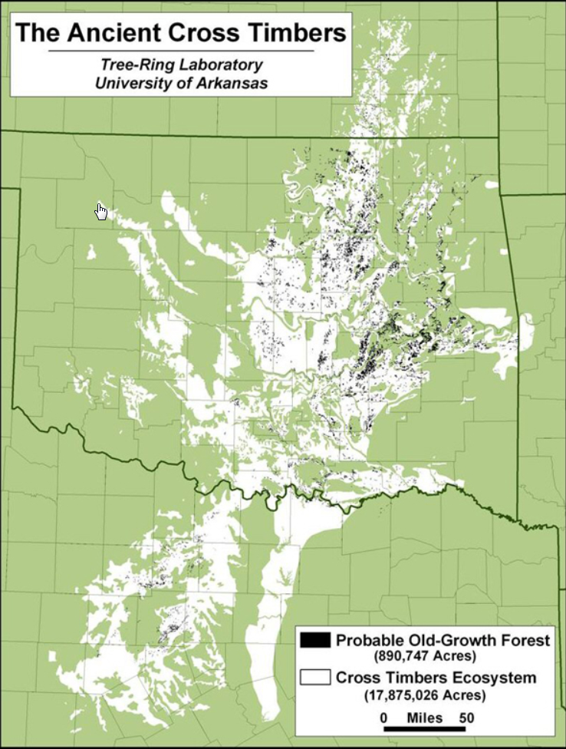
LLELA

CICADA TRAIL
- Name two venomous snakes found at LLELA. | Click or tap here to enter text.
- What kind of animal is a Cicada? | Click or tap here to enter text.
- What sound does a Cicada make? | Click or tap here to enter text.
- What is the State Tree of Texas | Click or tap here to enter text.

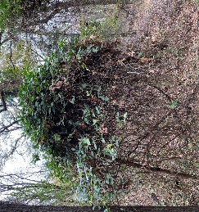  Find an example of this invasive vine along the trail, it can completely cover a small tree. what is it? Hint:( Japanese) ___________) | Click or tap here to enter text.
- Describe the color of one of the birds you see. | Click or tap here to enter text.
- Look carefully to the left of the trail just before the sign “Home is where the Rot Is.” Look for a wooden box and describe what you see. | Click or tap here to enter text.
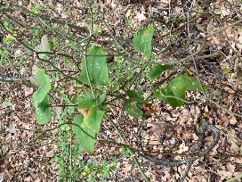  - Find this prickly native vine, it grows all over LLELA. what is its name? | Click or tap here to enter text.
- Take a picture of Sapsucker holes in Cedar Elm. (Hint: near the Sapsucker information sign.)

End of the Trail. Find two things:
- Tale a picture of a Poison Ivy “rope” going up a tree.
- What is the shape of the lock on an old rusty metal pipe at the end of the trail? (This is at the end of the trail) | Click or tap here to enter text.

Go back to the sign for the Cottonwood Trail and follow it to the overlook. Find two things:
11. What does the fence made-out of branches overlook? | Click or tap here to enter text.
- Try to find the small bird’s nest on the tip of a branch and take a picture
Follow the path so you are now on the Cottonwood Trail. Turn right if you wish to return to the parking lot. Turn left if you want to do the Cottonwood Trail.
If you are doing the Cottonwood Trail, then start at the last number and work backwards to #1.

COTTONWOOD TRAIL

- Common to the low laying areas of the Cottonwood Trail this large tree is a major part of the bottomland forest. Find it along the trail and take a picture.
What tree is it? ________
- What are the green clusters high in the trees? | Click or tap here to enter text.
- Name something that does not belong on the trails at LLELA | Click or tap here to enter text.

Area of the Cabin:
- What year did William Minor buy land in Highland Village? | Click or tap here to enter text.
- What year is on the sign about the Home Building Tools? | Click or tap here to enter text.
- What causes the small holes in the chimney of the Cabin? | Click or tap here to enter text.
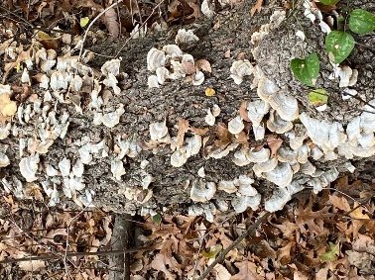  - This is a shelf fungus. They are members of the family Polyporales. What is their function in an ecosystem? | Click or tap here to enter text.
Bonus points: The major agents of decomposition are sometimes described as the FBI. The F stands for fungi. What do the B and I stand for? | Click or tap here to enter text.
- Lichens are made up of algae and fungus and grow on rocks and rotting logs. Take a picture.

- There are many evergreen trees along the trail. Identify one. | Click or tap here to enter text.

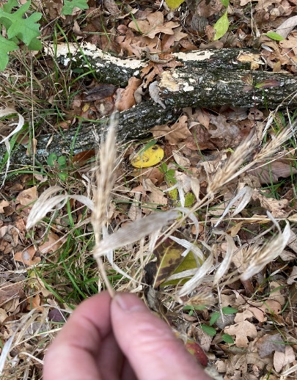  - This is the seed head of one of the few grasses that grows in the shade. Find one and take a picture.  - What grass is it? ______________ | Click or tap here to enter text.
- A squirrel’s nest is called a dray. Where would you find it? | Click or tap here to enter text.

BLACKJACK TRAIL

You can do this trail from the Blackjack Parking Lot either frontwards or backwards. The items are starting from the Kiosk (frontwards).
- What type of tree is Blackjack? | Click or tap here to enter text.
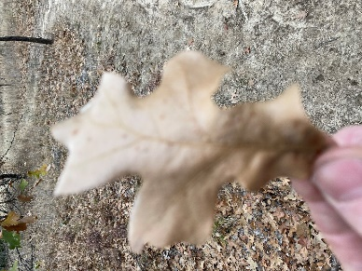
- Find an example of this cross shaped leaf. It comes from one of to the two most abundant oaks of the Crosstimbers. What oak tree is it from?
- What is Aldo Leopold’s Quote on the information sign on the Blackjack trail? First three words only. | Click or tap here to enter text.
- What causes the burrows/holes in the side of the creek? | Click or tap here to enter text.
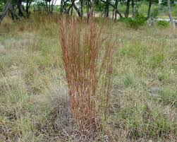
- Little bluestem is the most common grass in the prairie glades, find a stand and take your own picture.

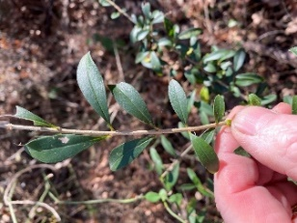  - Find an example and take a picture of this large, exotic, invasive shrub. What is it? (Hint: Chinese ______) | Click or tap here to enter text.
Bonus points: How can you tell the difference between it and the native yaupon holly (Ilex vomitoria)? | Click or tap here to enter text.
- Find a tree that has the markings of a "deer rub" on its trunk. Take a picture. Each whitetail deer has a truly unique set of antlers. No two are alike. And they’re much like a fingerprint in that regard.

- Find green moss growing on a tree, a rock or the ground. Take a picture.
Moss is a primitive plant that grows in dark, damp, shady places.
- Stuck in the middle of a trail. Find the tree that was in the center of the Blackjack Trail that was cut down to a mere stump with its exposed roots shaped like a sun. How many roots are coming from it? | Click or tap here to enter text.
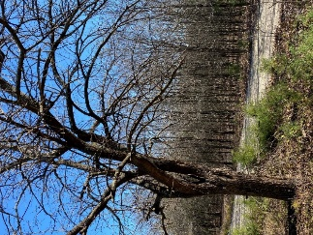  - This large deciduous tree is found all over LLELA. It is known by its arc shaped branches and large, ball-shaped green fruits. What is it? | Click or tap here to enter text.
- Look for either two hoofed deer tracks or a Prickly Pear Cactus. Take a picture of one of them.

- Many types of animal scat (poop) can be found along the trail. Describe one. | Click or tap here to enter text.
BONUS POINTS – GREEN DRAGON TRAIL

- Picture of big fallen vine that lays in the shape of a “B”.

- Picture of Tree Graffiti (from a human).

- Picture of tree with beetle “tunnels”.

Or Submit your answer sheet by emailing it to LLELAOutdoors@gmail.com,
Or leaving a “hard copy” at the LLELA Gatehouse.
Change the name of the entry/answer sheet so that
it includes your team name (Smithteam).

